WATER JUG PROBLEM

AIM: To implement python program for water jug problem.

OBJECTIVES:
- To measure a specific amount of water using two jugs of different capacities.
- To find a sequence of operations to reach the desired water quantity.
- To implement a state-space search technique for solving the problem.

ALGORITHM:
- Start with both jugs empty.
- Define the initial state as (0,0).
- Define the goal state (required amount of water).
- Perform possible operations such as Fill a jug completely, Empty a jug completely and Pour water from one jug to another.
- Store each new state and avoid repeating previous states.
- Continue generating states until the goal state is reached.
- Display the steps required to obtain the desired amount of water.

SYSTEM ARCHITECTURE:
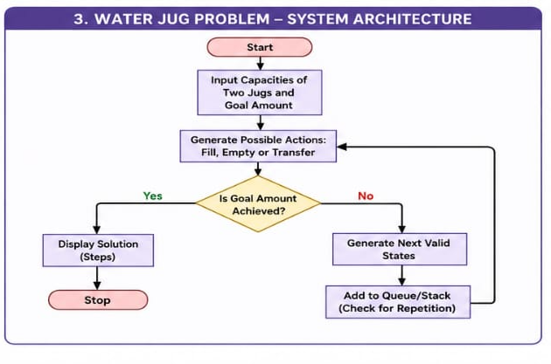

PROGRAM:
a, b = 4, 3
x = y = 0

while x != 2:
if x == 0:
x = a
elif y == b:
y = 0
else:
t = min(x, b - y); x -= t; y += t
print("Jug1 =", x, "Jug2 =", y)
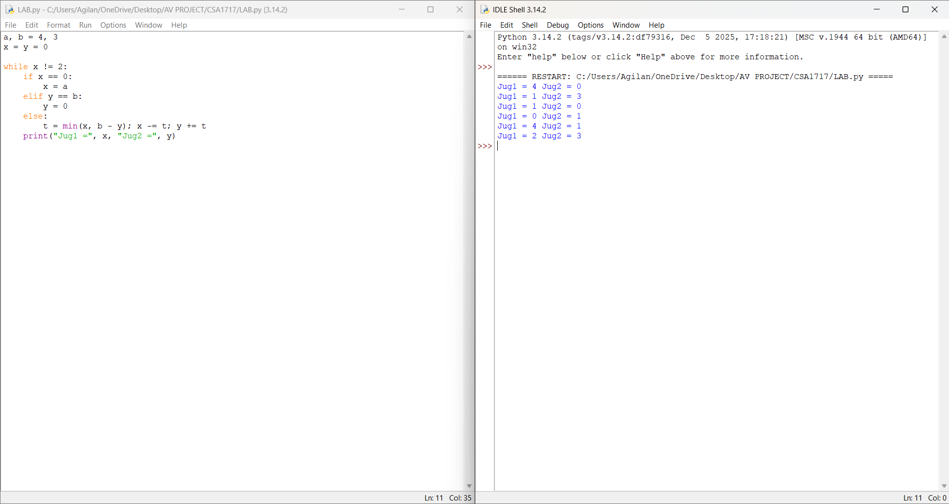
FIG.2: WATER JUG PROBLEM OUTPUT SCREENSHOT

RESULT: Thus the water jug problem is implemented successfully using python language.

